For IOM use only
Case number:
MiMOSA:
Date of application:
Date of travel:

VOLUNTARY ASSISTED RETURN AND REINTEGRATION PROGRAMME (VARRE)
Application
- Personal details:
Family Name _____________________________________________________________________
Given Name (s) ___________________________________________________________________
Date of Birth _______________________________(dd.mm.yy)
Citizenship (Resident permit in other countries?) _______________________________________
Return Country (city/village) ________________________________________________________
Contact Details: Tel._________________________Whatsappp/Viber/etc. ____________________
E-mail (or other contact)____________________________________________________________
Valid Travel Document (Passport):
Yes | Valid until: | No

If no, why? □ Never had any / □ Lost / □ Someone took it – Who? ______________________

- Family details:
What is your marital status? □ Single / □ Married / □ Divorced / □ Co-habiting
Do you have children under the age of 18? How many? □ Yes / □ No __________________________
Family members travelling with you: □ Yes / □ No
- Education and work experience:
What is your highest level of completed education? __________________________________________
What languages do you speak? ___________________________________________________________
What is your profession or work experiences? ______________________________________________

Are you the sole or primary provider for your household? □ Yes / □ No
Do you have any debts? □ Yes / □ No

- Your Status in Estonia:
- Withdrawing Asylum Process
- Rejected Asylum Seeker
- Irregular entry
- Irregular stay
- Foreign student
- Foreign worker
- Other _______________________________________________________________________
- Why did you migrate/leave home?
- Look for work
- Look for education
- Look for health care
- Conflict, insecurity
- Bad family situation (explain) __________________________________________________
- Persecution
- No choice (explain) ____________________________________________________________
- Romantic relationship/marriage
- Family reunification
- Natural disaster
- Other (specify) ________________________________________________________________
- Do you have enough resources to meet your basic needs (food, housing, etc.) before return?
□ Yes / □ No
- Do you have a physical or mental disability, are you currently sick or injured, or do you have medical needs that we should take into consideration organizing your return?

□ Yes / □ No Specify: ________________________________________________________
- Do you need to have special diet? □ Yes / □ No ___________________________________

- How did you get information about the program? ___________________________________

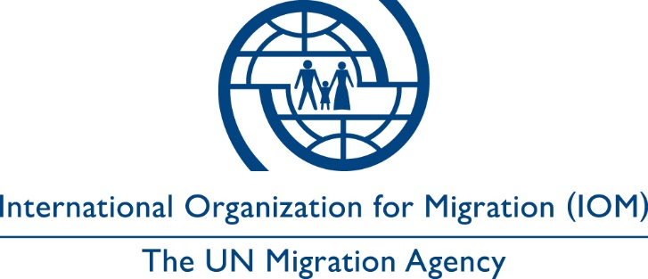

Voluntary return declaration form

Voluntary Assisted Return and Reintegration Programme from Estonia

I, the undersigned, ________________________________________________ hereby express my will to return to my home country or a third country (where I am entitled to permanent residence), which is___________________________, through the assistance of the International Organization for Migration (hereinafter IOM) within Voluntary Assisted Return and Reintegration Programme from Estonia (VARRE), which is co-funded by the European Asylum, Migration and Integration Fund (AMIF) and Estonian Ministry of the Interior.

I confirm that I have been informed about the assistance that I will receive and the conditions of the voluntary return process.

I understand that the assistance provided under this programme does not include the possibility to remain in any transit country. I understand that I may be interviewed and/or questioned by national authorities upon arrival. I further understand that IOM will not be in a position to interfere with rules and procedures established by airport or immigration authorities in transit or upon arrival.

I acknowledge, for myself and for any person for whom I have the right to do so as well as for relevant heirs and estate, that IOM will not be held liable for any damage caused, directly or indirectly, to me or any such person in connection with IOM assistance that derives from circumstances outside the control of IOM.

I hereby authorize IOM and any authorized person or entity acting on behalf of IOM to collect, use, disclose and dispose of my personal data and, where applicable, the personal data of my dependants ______________________________________________________ for the following purposes:

PURPOSES  Specified and defined prior to data collection | DESCRIPTION | CONSENT
 | To be filled in by data controllers/interviewers | YES | NO
- Assisted voluntary return | Providing assistance to return voluntarily to one’s country of origin.
- Additional assistance | Using data to provide additional assistance under other IOM projects
- Research | Using data for research purpose
- Other

I agree that my personal data may be disclosed to the following third parties: Estonian Police and Border Guard Board, Embassy of your country (in case of issuing temporary travel document) and to the donor (Estonian Ministry of the Interior) to achieve the purpose(s) specified above. I understand that I may access and rectify my personal data on request by contacting IOM.

I declare that I have shared with IOM all information on any medical condition that may affect my and other persons’ well-being during the voluntary return and reintegration process. I also declare that, should the before described information change in the period prior to my departure, I will promptly inform IOM.

I declare that the information I have provided is true and correct to the best of my knowledge. I understand that if I make a false statement in signing this form, IOM may not be able to provide the assistance.

Applicant’s (or legal representative) signature |  | Date and place
Interpreter’s signature [if applicable]: |  | Date and place
Signature of the Representative of IOM |  | Date and place

This purpose will need to be defined at the beginning of the project/ signing of the form and can then not be changed anymore.

